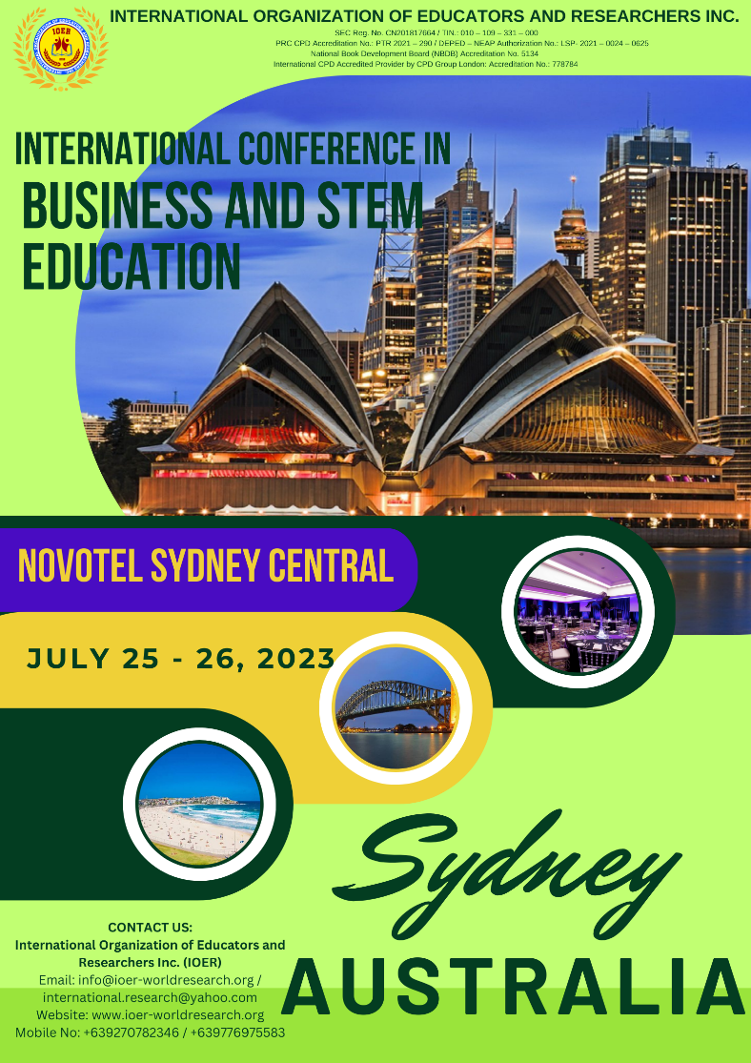
INTERNATIONAL CONFERENCE IN BUSINESS AND STEM ( Science, Technology, Engineering, Mathematics) EDUCATION
Novotel Sydney Central
169-179 Thomas Street – Sydney NSW 2000
July 25 – 26, 2023

ICMSTEME Conference Registration Link
https://forms.gle/8JuUC1iAUXM9ukcL6

